ANSWER KEY: NASA Centers and Facilities

Directions for NASA Centers:
Match the center with its location on the U.S. map by writing the letter next to the name of the center.

U.S. Map
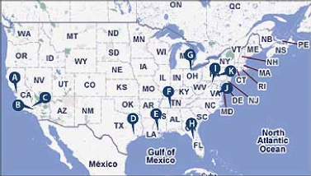
NASA Centers
- A Ames Research Center  - C Dryden Flight Research Center  - G Glenn Research Center  - K Goddard Space Flight Center  - I NASA Headquarters  - B Jet Propulsion Lab | - D Johnson Space Center  - H John F. Kennedy Space Center  - J Langley Research Center  - F Marshall Space Flight Center  - E Stennis Space Center

Directions for NASA Facilities:
Match the facility with its location on the U.S. map by writing the letter next to the name of the facility.

U.S. Map
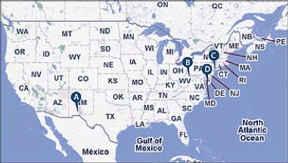
NASA Facilities
- B NASA IV&V Facility
- C Goddard Institute for Space Studies
- D Wallops Flight Facility
- A White Sands Test Facility

Of all of the NASA locations, where would you like to live and work? Explain why you chose that location and what type of job you think you might like to perform.

Answers will vary.

